Chapter 3 Research Design and Methodology
This chapter tells the examiner HOW the research was done, in order to achieve the research objectives.
So, it’s about HOW the research objectives were operationalized and a justification i.e. the WHY
The chapter is written in Past Tense and structured using the Wilson Honeycomb Model.
1300 words

3.0 Introduction
Define Research Design. Discuss the importance of using an appropriate research design (Wilson pg. 172)
Use the Honeycomb Model (Wilson 2013) to outline the typical contents of the chapter.

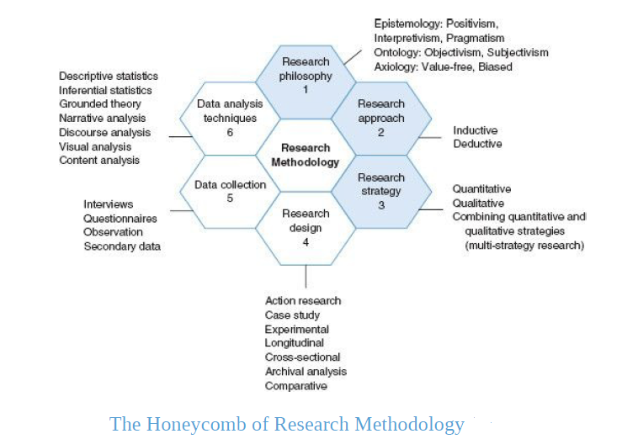

3.1 Research Paradigm (see pg. 36-50 Wilson text)
Define Research Paradigm, use at least 3 authors to do so. Make sure to say at some point in the discussion that one’s paradigm choice is influenced by key philosophical assumptions of Epistemology and Ontology

3.1.1 Research Philosophy
>Start with a discussion of Epistemology- Knowledge and Knowing
Decide on whether you are using a Interpretivism OR Positivistic paradigm OR Pragmatism
> Move on to the idea of Ontology- Reality
Discuss whether your research will be based on an Objective or Subjective stance.
Justify your choices by using literature and apply to your research context.
It might be useful to say why the other cannot work or why it might not be applicable

3.1.2 Research Approach
Define both Inductive and Deductive Approaches
Must discuss whether you are using Inductive or Deductive role of theory
It is important that you justify your choice given the context of your research
It might be useful to say why the other cannot work or why it might not be applicable

3.1.3 Research Strategy
Define Quantitative, Qualitative and Mixed Methods
You must then relate that to whether you are following a Quantitative or Qualitative approach or Mixed Methods
Justify your choices by using literature and apply to your research context.
It might be useful to say why the other cannot work or why it might not be applicable

3.2 Research Design (see pg. 172 Wilson Text)
> Discuss your use of Secondary Research design i.e. Desk-based
What is it, its strengths and limitations
How it was applied to your research using ONE of the following:

Desk-Based Research Design | Core Purpose | Typical Data Sources | Analytical Techniques
Archival Financial Statement Analysis (AFSA) | Examine relationships and trends using historical corporate financial data | Annual reports, financial statements, notes to accounts, ESG reports | Ratio analysis, trend analysis, correlation, regression
Secondary Quantitative Econometric Analysis | Test finance/accounting theories using existing numerical datasets | Stock returns, firm-level databases, macroeconomic datasets | Regression, time-series analysis
Document-Based Regulatory and Policy Analysis | Evaluate accounting, auditing, and regulatory frameworks | Accounting standards, audit standards, policy papers, enforcement reports | Qualitative content analysis
Comparative Accounting Systems Analysis | Compare accounting regimes, standards, or practices across contexts | IFRS vs US GAAP texts, country regulations, comparative studies | Comparative thematic analysis, cross-jurisdictional comparison
Structured / Systematic Literature Review (SLR) | Map, synthesise, and critically evaluate prior research | Peer-reviewed journal articles from academic databases | Systematic screening, thematic analysis
Thematic Secondary Case Analysis | Explore accounting or audit phenomena through documented cases | Regulatory enforcement cases, corporate scandal reports, legal judgments | Qualitative coding, pattern matching

Use a range of literature sources to discuss HOW it was used and remember to apply to your research context.

3.3 Data Collection (see pg. 264 Wilson text)
Give a brief introduction into the general purpose of data collection in order to achieve the research objectives.
Then clearly state that this research was conducted using secondary data only.
Define secondary data, Discuss the advantage and disadvantage of using secondary data.
Discuss HOW these sources and documents were evaluated for validity and reliability.
Discuss the type of secondary data you used i.e. whether it was specific to an organization publicly available i.e. company annual report or from other external sources e.g. Journals, Industry report, government publication, financial intelligence databases. See table above [Typical data sources]
Must give the time horizon of your research, i.e. either you used Longitudinal data or Cross Sectional data or Panel data.
Give a summary, mapping each research objective to the data collected, use the methodology matrix
Research Objective | Key Concepts / Variables | Data Sources (Secondary) | Method of Analysis
1.
2.
3.

3.4 Data Analysis Plan
So you have collected secondary data which may be in a Quantitative e.g. from a survey done by a national body, professional body, a journal article or from financial sources. You may have also collected Qualitative Data e.g. from a journal article that used interviews or an interview done by Financial Times or even from YouTube.
How did you analysed it? What techniques did you use? Only discuss techniques actually used.
NB: Given that you are doing Accounting, Finance and Banking topics, you are most likely going to use Quantitative Analysis.

Quantitative Analysis (see pg. 318 Wilson text)
Discuss the use of Descriptive Statistics- Tables, Distribution Frequencies, Cross Tabulation, Central Tendency (Mean, Median, Mode), Scatter Diagrams, Graphical Forms (Pie, Bar etc.), Regression Analysis, t-test.
NB: Only discuss the techniques used. Also, if you used Ratio Analysis or any other specific Finance technique, then explain the process

3.5 Ethics (see pg. 139 Wilson text)
Define Ethics in Research
Since you used only secondary data there were no ethical issues regarding privacy and confidentiality of the data used.
But there are 2 ethical issues when using secondary data- 1. Plagiarism and 2. Mis-representing the data. So, make sure to discuss this and how you will mitigate both.
Additionally, that you completed the Ethics Training, refer to the Ethics Quiz Certificate in the appendix
https://anglia-ruskin-university.learnworlds.com/course?courseid=researchprofethics

3.6 Limitations to Research Methodology
Every methodology would have some limitations
Discuss the Issues that might affect the quality of the research i.e. Reliability and Validity
So, discuss the limitations of using Secondary Data ONLY

